+Introduction
PROJECT DESCRIPTION
The project entitled as “WATER SUPPLY MANAGEMENT SYSTEM” for Mineral Water Supply agency. The maintenance of each and every detail manually is a toughand tedious process. The main objective of this project is to computerize the activities performed in the concern. In this system viewing and updating of regular customer details,water bottle supplier details, stock details, sales details and employee details is easy because it reduces manual work.
This system is helpful in maintaining the record of customers. This project is developed in order to help the management to keep their overall records such as staff details and area office details etc., the details are maintained by the secured login.
The administrator can view all the details and the details can also be updated. Thus the project helps the mineral water management to maintain their records. It is developed using Visual Basic 6.0 and Microsoft Access 2010.
Water Supply Management System has Following Key feature:
Admin Login
Home Page
Product Details
Order Management
Receipt Details
Search
Report
Statement of Problem
Most suppliers lack the technical expertise to dispense their duties, the manual system of managing supply records makes the business difficult to manage. Inability to instantly determine customers to supply to that booked for the product for a particular date.. Unclear specifications or careless supplier specification, lack of detailed information of the customers that need the product and their specific demand. The purchasing and supply department of many business organizations lack clear rules and guidelines with regard to procurement and supply governance. It is in view of these problems that this research study is carried out.
Statement of Problem
Most suppliers lack the technical expertise to dispense their duties, the manual system of managing supply records makes the business difficult to manage. Inability to instantly determine customers to supply to that booked for the product for a particular date.. Unclear specifications or careless supplier specification, lack of detailed information of the customers that need the product and their specific demand. The purchasing and supply department of many business organizations lack clear rules and guidelines with regard to procurement and supply governance. It is in view of these problems that this research study is carried out.
Significance of the study
This study is significant in the following ways:
It will aid the management of Terry water company to properly manage the records of supplies to be made on a daily basis. The system will enable the water company to be able to determine who they have supplied to and those that are still pending. It will provide an easy way of updating and verifying supply records of customers. The system will serve as a management information system to the management of terry water company. The study will serve as a useful reference material to other researchers and academicians seeking related information on supply management.
Organization of the Research
This research work is organized into five chapters.
Chapter one is concerned with the introduction of the research study and it presents the preliminaries, theoretical background, statement of the problem, aim and objectives of the study, significance of the study, scope of the study, organization of the research and definition of terms.
Chapter two focuses on the literature review, the contributions of other scholars on the subject matter is discussed.
Chapter three is concerned with the system analysis and design. It presents the description of the existing system, analysis of the proposed system and system design..
Chapter four presents the system implementation and documentation, the choice of programming language, analysis of modules, choice of programming language and system requirements for implementation.
Definition of Terms
Demand: The amount of a good or service that consumers are willing to buy at a particular price.
Database Application: A software program for storing, retrieving and manipulating a database.
Supply: To provide, give, sell, or make available something that is wanted or needed by somebody or something.
Management: Administration of business, the organizing and controlling of the affairs of a business or a sector of a business.

Abstract:
The water is the life line for nature and human. The water wastage is main Concern across the country. The main region behind the water wastage is poor water supply system and bad management. The paper is innovative step to digitalize the water supply system throughout the city as well as villages. A step to improve the water supply system, which sets a platform to make everyone “Save Water”. The real time water supply system will control the water flow at each area according to time scheduling.

Problem Definition
The water supply problems which have been identified within the Region are related to the capacities of the existing water supply infrastructure to meet forecast water supply demands and to the quantity and quality of the groundwater supplies, and the sustained ability of those supplies to meet probable future needs. Each of the identified problems is described in the following sections, along with the related planning objectives and standards and the recommended basis for resolution. The identified problems are to be specifically addressed and abated or resolved in the regional water supply plan.
EXISTING SYSTEM
EXISTING SYSTEM
In the existing system, all the operations are done only manually and hence take manyefforts in the process of information passing. Since all the details have to be maintain tomanage the system each and every records like customer details, courier details, and shippingdetails, return details and payment details have to be maintained. In the existing systemthough making entries is easy but recollecting information about courier or customer detailsis a tough task. Hence a new system has to be developed to maintain all the data.
PROPOSED SYSTEM
The aim of proposed system is to develop a system of improved facilities. The proposed system can overcome all the limitations of the existing system. The system provides proper security and reduces the manual work. The new system can maintain all the data easilylike customer details, employee details, stock details, sales details, etc,. Retrieval of anyinformation from the system is very quick and easy process.
ADVANTAGES
The system is very simple in design and to implement. The system requires very low system resources and the system will work in almost all configurations. It has got following features. All the details are stored according to their id in every module for easy retrieval.
Computerized maintenance of records.
Daily transactions and payment details are updated daily.
Records are safe and secure.
Consumes very small amount of time.
Requires low man power.
Any information can be fetched easily.
If any water bottle product had been damaged or not delivered on time or any other reasons, the reason for bottle return will be updated.
Disadvantages:
- Rainfall is unpredictable.
- Water tanks can be very hard clean.
- You may have to refill your water tank, so it may cost you money.
- Some cleaning systems cost a lot of money.
- You can't collect as much water as you like, as it over flows.
- Water tanks have a high chance of getting dirty.

PROPOSED SYSTEM
Feasibility Study
TOOLS AND TECHNOLOGIES USED
Front – End: - Visual Studio Windows Form

Portability

Composition

Processing

Access Models
Back-End: - MySQL 5.0
HARDWARE AND SOFTWARE REQUIREMENTS Specification
Hardware Requirements
- processor: Intel core i3 6100t or Above Version.
- RAM : 4GB Or 8GB
- Monitor
- Mouse
- Operating System: Windows 7, Windows 8, Windows 10 or above version.

Software Requirements
- Operating system : Windows 7, Windows 8, Windows 10 or above version.
- Coding Language : VB.NET (Windows Form Application) 2010
- Database : XAMPP – 8.2.12, MySQL – 5.0
INTRODUCTION
OVERVIEW OF THE PROJECT
The project entitled as “WATER SUPPLY MANAGEMENT SYSTEM” for Mineral Water Supply agency. The maintenance of each and every detail manually is a toughand tedious process. The main objective of this project is to computerize the activities performed in the concern. In this system viewing and updating of regular customer details,water bottle supplier details, stock details, sales details and employee details is easy because it reduces manual work.This system is helpful in maintaining the record of customers. This project isdeveloped in order to help the management to keep their overall records such as staff details and area office details etc., the details are maintained by the secured login. The administrator can view all the details and the details can also be updated. Thus the project helps the mineral water management to maintain their records. It is developed using Visual Basic 6.0 and Microsoft Access 2010.
The modules of this project are,

Customer Details

Employee Details

Stock Details

Sales Details

Supplier Details
Project Modules
Dashboard: In this section admin can see all detail in brief like total order, total new order, total accept order, total order deliver, total cancel order, total company and total register user.
Water Bottle info: In this section admin can manage water bottle(Add/Update/Delete).
Company Info: In this section admin can manage company(Add/Update/Delete).
Pages: In this section admin can update about us and contact us information.
Orders Management: In this section admin can view the order details and they have also right to change order status according to current status.
Latest News/Updates: In this section admin can manage news(Add/Update/Delete).
Reg Users: In this section admin can view registered users and their orders.
Search: In this section admin can search particular order with the help of order number.
Reports: In this section admin can view order details, order counts and sales report according to dates.
Admin can also update his profile, change password and recover password.
User
1.Water Bottle: In this section user can view which drinking bottle available.
2.My Accounts: In this section user can change his/her own password , view and update his/her profile and logout from accounts.
3.My orders: In this section user can view order history after login.
4.Cart: In this section user can add their drinking bottle which he/her want to order.
5User has also a facility to download his/her invoice and cancel order if he/her want to cancel.
Brief Information about homepage
On this page guest user can only view about us page, contact us page and which drinking bottle is available if anybody want to order the bottle they must registered.

MODULE DESCRIPTION
CUSTOMER MODULE
This module is used to maintain the details regarding the customers of the water plant.
EMPLOYEE MODULE
This module is used to maintain the details regarding the employees who work in thewater plant.
STOCK MODULE
This module is used to maintain the details regarding the water plant stock present inthe warehouse.
SALES MODULE
This module is used to maintain the details regarding the sales occurred during everyday and year of the water plants.
SUPPLIER DETAILS
This module is used to maintain the details regarding the water plant suppliers.
2. SYSTEM ANALYSIS
System analysis is a process of gathering and interpreting facts, diagnosing problemsand the information to recommend improvements on the system. It is a problem solvingactivity that requires intensive communication between the system users and systemdevelopers. System analysis or study is an important phase of any system development process. The system is studied to the minutes detail and analyzed. The system analyst playsthe role of the interrogator and dwells deep into the working of the present system. Thesystem is viewed as a whole and the input to the system are identified. The outputs from theorganizations are traced to the various processes. System analysis is concerned with becoming aware of the problem, identifying the relevant and decisional variables, analyzingand synthesizing the various factors and determining an optimal or at least a satisfactorysolution or program of action.
2.1 EXISTING SYSTEM
In the existing system, all the operations are done only manually and hence take manyefforts in the process of information passing. Since all the details have to be maintain tomanage the system each and every records like customer details, courier details, and shippingdetails, return details and payment details have to be maintained. In the existing systemthough making entries is easy but recollecting information about courier or customer detailsis a tough task. Hence a new system has to be developed to maintain all the data.
2.1.1 DRAWBACKS OF THE EXISTING SYSTEM

Manual record is maintained.

Finding of specific information is a tedious process.

Daily transactions will not be updated.

Consumes more time.

Requires large man power.

Records will not be safe and secure.To avoid all these limitations and make the working more accurately the system needs to be computerized.
2.2 PROPOSED SYSTEM
The aim of proposed system is to develop a system of improved facilities. The proposed system can overcome all the limitations of the existing system. The system provides proper security and reduces the manual work. The new system can maintain all the data easilylike customer details, employee details, stock details, sales details, etc,. Retrieval of anyinformation from the system is very quick and easy process.
2.2.1 ADVANTAGES OF THE PROPOSED SYSTEM
The system is very simple in design and to implement. The system requires very lowsystem resources and the system will work in almost all configurations. It has got followingfeatures

All the details are stored according to their id in every module for easy retrieval.

Computerized maintenance of records.

Daily transactions and payment details are updated daily.

Records are safe and secure.

Consumes very small amount of time.

Requires low man power.

Any information can be fetched easily.

If any water bottle product had been damaged or not delivered on time or any other reasons, the reason for bottle return will be updated.
2.3 SYSTEM SPECIFICATION
2.3.1 HARDWARE REQUIREMENTS
Processor:Intel Pentium Dual coreHard disk:40 GBCD drive:680 MBPrinter:Laser Printer (Canon)Ram:256 MBMouse:LogitechMonitor:17” color monitor Keyboard:110 keys
2.3.2 SOFTWARE REQUIREMENTS
Operating system:Windows 7Front end:Visual Basic 6.0Back end:Microsoft Access 2010
2.3.3 ABOUT THE SOFTWAREABOUT THE FRONT ENDVisual Basic
Visual Basic is an ideal programming language for developing sophisticated professional applications in Microsoft windows. It makes use of the Graphical User Interfacefor creating robust and powerful applications. The Graphical User Interface usesillustrations to enable users to interact with the applications. This feature makes it easier tocomprehend things in a quicker and easier way. Programmers everywhere use this dynamicand efficient tool to create professional quality applications for the windows desktop. With itssleek approach to development, Visual Basic inspires creativity, resulting in programs thatlook better and work more reliably.
MARVEL functionality provided Visual Basic
Modular Programming
– Visual Basic allows modularization through user-definedsub routines and functions. The Visual environment forces a certain amount of modularity.The VBX files provided by the various vendors allow easy access in hung pieces of functionality, with little coding.
Automated Interfaces
– Visual Basic supports automated interfaces throughargument passing, which allow subroutines and functions to be called from another program.
Rethinking
- Visual Basic does for programmers what Windows does for users. Itmakes their job easier and less tedious. The visual environment allows the programmer tofocus much more on the problem at hand rather than the structure of interfaces.
Visual Development Environment
– Visual Basic is one of the easiest visualenvironments to use. All of its controls work in a consistent way. Their properties and eventscan be easily selected from a list box. It does not force a programmer to remember muchmore than the basics.
Extensibility
– Visual Basic has by far the most complete extensibility of any producton the market. VBX files are being designed and written by a multitude of third-partyvendors to interface their own products. While each of these VBX files performs dramaticallydifferent functions, all are implemented and used by Visual Basic Programmer in the sameway.
Linking –
Visual Basic supports all the necessary forms of DDE to link wholeapplications modularly into a single application. Visual Basic also supports OLE as a client,which allows modular use of data from another program.
Programming Using Visual Basic
Coding in GUI environment is quite a transition from traditional linear programmingmethods, where the user is guided through a linear path of execution and is limited to a smallset of operations. In a GUI environment, the number of options open to the user is muchgreater, allowing more freedom to the user. Features such as easier comprehension, user-friendliness, faster application development and many other aspects make Visual Basic aninteresting tool to work with. Using Visual Basic, we can create powerful, full-featuredapplications that exploit the key features of Microsoft Windows, including MultipleDocument Interfaces.
Visual Basic is not exclusively designed for technical experts. It meets the need of anyone, programmer or not, who has the creative impetus to design a new application. Wecould still use the tools of VB to shape our program. Working in VB is much more easier than using any other Windows applications.Program development in VB is a three-step process. Only the final step-coding-requires the expertise and experience of a programmer. The first two steps can be carried out by anyone who has an idea for a program – small or large, simple or complex, single-purposeor multifaceted. The three steps are as follows:

Designing the appearance of the programs

Assigning properties to the objectives of the program

Writing the code to carry out the specific tasks
Multiple Document Interfaces
The Multiple Document Interfaces (MDI) allows a developer to create applicationsthat maintain forms within a single container form. Applications such as Windows ProgramManager, Windows File Manager etc., have MDI’s. An MDI application allows the user todisplay multiple documents at the same time, with each document displayed in its ownwindow. Document windows are contained in parent window, which provides a workspacefor all windows in the application.
ABOUT THE BACK ENDMICROSOFT ACCESS
A database is a collection of data and object related to particular purpose. MS Accessis a Relational Database Management System [RDBMS]. A database is a program for storingand manipulating data.Microsoft Office Access, previously known as Microsoft Access, is adatabasemanagement system fromMicrosoft that combines the relationalMicrosoft Jet DatabaseEngine with agraphical user interface and software-development tools. It is a member of theMicrosoft Office suite of applications, included in the Professional and higher editions or soldseparately.Software developers anddata architects can use Microsoft Access to developapplication software, and " power users" can use it to build software applications. Like other Office applications, Access is supported byVisual Basic for Applications, anobject-oriented
waterfall model.
The waterfall Model outlines the product advancement prepares in a straight consecutive stream; subsequently it is likewise alluded to as a direct successive life cycle model. This implies that any stage in the advancement procedure starts just if the past stage is finished.
Taking after is a diagrammatic representation of diverse periods of waterfall model.
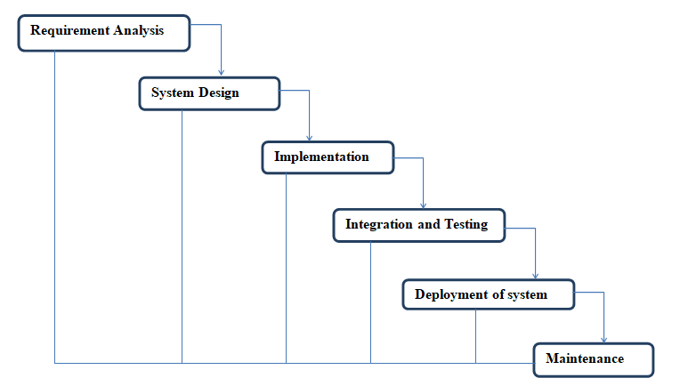
The successive stages in Waterfall model are:
- Requirement Gathering and analysis: Every conceivable prerequisite of the framework to be produced are caught in this stage and reported in a necessity particular doc.
- System Design: The prerequisite details from first stage are contemplated in this stage and framework configuration is arranged. Framework Outline helps in determining equipment and framework prerequisites furthermore helps in characterizing general framework structural engineering.
- Implementation: With inputs from framework plan, the framework is initially grown in little projects called units, which are coordinated in the following stage. Every unit is created and tried for its usefulness which is alluded to as Unit Testing.
- Integration and Testing: All the units grew in the execution stage are incorporated into a framework subsequent to testing of every unit. Post reconciliation the whole framework is tried for any issues and disappointments.
- Deployment of system: Once the practical and non-useful testing is done, the item is conveyed in the client environment or discharged into the business.
- Maintenance: There are a few issues which come up in the customer environment. To alter those issues patches are discharged. Likewise to upgrade the item some better forms are discharged. Upkeep is done to convey these adjustments in the client environment.

Every one of these stages are fell to one another in which advance is seen as streaming consistently downwards (like a waterfall) through the stages. The following stage is begun strictly when the characterized arrangement of objectives are accomplished for past stage and it is closed down, so the name "Waterfall Model".

DATA FLOW DIAGRAM
The dataflow diagram (DFD) is one of the most important tools used by systemanalysts. Data Flow diagrams are made up of a number symbols, which represent systemcomponents. Most dataflow modelling methods use four kinds of symbols. These symbols areused to represent four kind of the system components processes, stores ,data flows andexternal entities Circles in DFD represent processes, data flow represented by a thin line inthe DFD and each data store has a unique name and represented by open rectangles andsquare are rectangle represents external entities.

programming language that can reference a variety of objects including DAO (Data AccessObjects),ActiveX Data Objects, and many other ActiveX components. Visual objects used informs and reports expose their methods and properties in the VBA programmingenvironment, and VBA code modules may declare and call Windowsoperating-systemfunctions.MS Access stores data in its own format based on the Access Jet Database Engine. Itcan also import or link directly todata stored in other applications and databases.
Entity
This is to describe the conceptual data units or objects represented rectangles.
Relationship
It represents real-world associates among one or more entities. These are representedas diamonds.
Uniqueness and keys
In MS-Access, the Master Database (MDB) file contains number of tables. Each tablecontains rows and columns. The relational model dictates that every row in a database must be unique.
Primary key
A primary key is made up of one or more attributes whose value uniquely identifiedeach record in the table. In a relationship, a primary key is used to refer to specific records ina table. A primary key is called a foreign key, when it is referred from another table.
Data integrity
Enforcing data integrity involves presenting the consistency and correctness of data stored inthe database by,

Validating the contents of individual fields.

Validating data in one table with respect to one another.
Data types in Ms Access
The following are the data types are used in MS Access,

Text

Queries
Query is used to extract information from the table based on performing certainconditions. This is mainly used for reports. In this query we can include more than one tableat a time.
Forms
A form is used to get a record from user in specific format. Using forms we can displayrecords in specific manner. In forms we can set layout properties and data properties. Usingforms we can design the fields in text box and check box for selecting a list of options andradio or push buttons used for selecting a single option at a time.
Reports
In MS Access, the records in database are prepared for reports. Each record is set inspecific place. In the reports, we can include needed fields only. After viewing the reports,the records can be printed in a specific manner.

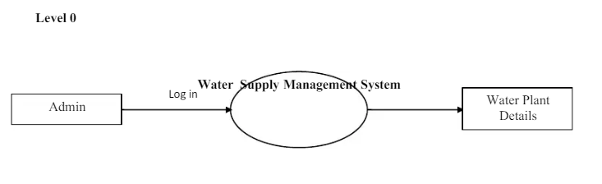
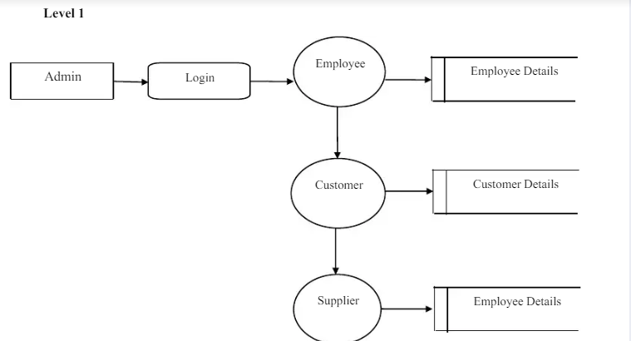
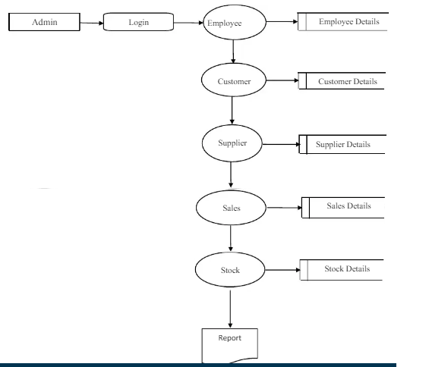
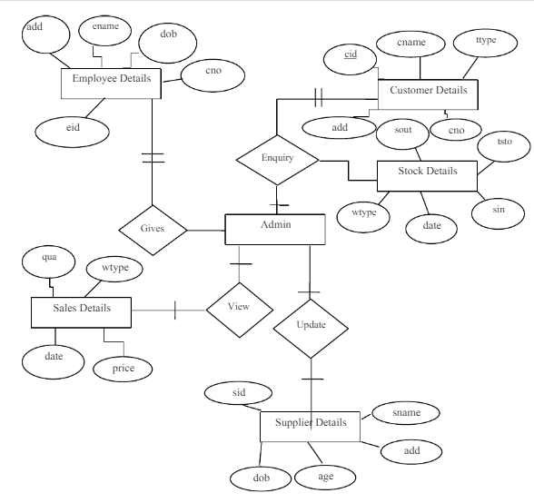
DESIGN PROCESS
Design should improve the system’s relationship with the user and help in decision-making. It is primarily required to communicate the user’s input from client side to the server where a program will be run to process the input. Once the output requirements aredetermined, the system design can decide what to include in the system.The most creative and challenging phase of the system life cycle is system design.System design is a process of developing specifications for a candidate system that meet thecriteria established in the system analysis. Design requires a full understanding of the problem and hence there is need for analysis of requirement and resources.
3.2.1 INPUT DESIGN
Data Structuring is defined through a process called normalization. Data are groupedin the simplest way, so that later changes can be made with a minimum impact on the datastructure. The normalization of these entities into attributes linked by common data elementsto form relationships improves the effectiveness of database management system.Mineral Water Distribution System considered the following facts while designing the input.They are

Types of inputs user going to enter.

User may do an error while entering the input data or values.

Automatic validation process to the input data should undergo

Make user easy to understand what to enter.

User can fail to spot one or two fields without entering the data in that fields.A good input design should have the following qualities above mentioned. Here in MineralWater Distribution System all these qualities are included while designing the input forms.Mineral Water Distribution System has the following input forms they are

Customer Details

Employee Details

Supplier Details

Stock Details
15
AD
Download to read ad-free.
AD


Sales Details
Customer Details [fig:3]
This module is used to maintain the details regarding the customers of the water plant.
Employee Details [fig:4]
This module is used to maintain the details regarding the employees who work in thewater plant.
Supplier Details [fig:5]
This module is used to maintain the details regarding the water plant suppliers.
Stock Details [fig:8]
This module is used to maintain the details regarding the water plant stock present inthe warehouse.
Sales Details [fig:6]
This module is used to maintain the details regarding the sales occurred during everyday/week and year of the water plants..
3.2.2 OUTPUT DESIGN
The important objective of a system is to generate reports based on queries; outputs formcomputer systems are primarily to communicate the result of processing to the users. Theoutput design should be well formatted, so that it contains all the required information andshould be well formatted and avoiding all complexity in getting information resulting from processing.The output design was done so that the result of processing could be communicated to theusers. The accuracy requirement of the data was also defined in the output.
REPORTS
The Data Report is known as an ActiveX Designer, meaning that it is a specializedActiveX object that integrates into the VB environment. Data report enable one to easily
16
AD
Download to read ad-free.
AD

display a print preview screen, with print and export buttons. To add information to thereport, first draw the report control in the appropriate section of the report and then set its properties, just like any other control. The Data Report includes some predefined placeholders, which allow including several dynamic elements on a report.Several screens can perform it. Computer output is most important and direct sourceof information to the user. Efficient, intelligible output design should improve the system’srelationship with the user and help in decision making. A major form of output is the hardcopy from the printer.The various output screens in the project are
Customer Details Report [fig:9]
This module is used to maintain the details regarding the customers report of the water plant.
Employee Details Report [fig:10]
This module is used to maintain the details regarding the employees report who work in the water plant.
Supplier Details Report [fig:11]
This module is used to maintain the details regarding the water plant suppliers report.
Stock Details Report [fig:12]
This module is used to maintain the details regarding the water plant stock report.
Sales Details Report [fig:13]
This module is used to maintain the details regarding the sales occurred during everyday/week and year of the water plants.
3.2.3 DATABASE DESIGN
The database design involves creation of tables. Tables are represented in physicaldatabase as stored files. They have their own independent existence. A table consists of rowsand columns. Each column corresponds to a piece of information called field. A set of fieldsconstitutes a record. The record contains the entire information specific to a particular item.
17
AD
Download to read ad-free.
AD

TABLE DESIGNTable Name:
Customer Details
Field NameData typeSizeDescription
cidNumber10Customer IDcnameText20Customer NameGenText10Gender of the Customer ttypeText10Transaction TypeAddText50Address of the Customer mnoNumber10Mobile Number
Table Name:
Employee Details
SYSTEM TESTING AND IMPLEMENTATION
4.1 SYSTEM TESTING
Software testing is a critical element of software quality assurance and represents theultimate review of specification, design and coding. Testing is a process of executing a program with the intent of finding errors. The user tests the developed system and change ismade according to their needs. The testing phase involves the testing of developed systemusing various kinds of data.The term implementation has different meanings, ranging from the basic application,to a complete replacement of a computer system. Implementation used here is to mean the process of converting a new system design into an operational one. Conversion is one aspectof implementation.
SYSTEM DEVELOPMENT
Maintenance is the engine of the system development. It holds the software industrycaptive, trying up programming resources. Analysts and programmers spent far more time problems, than they do writing them. Maintenance is not as rewarding and exciting asdeveloping a system. Software maintenance is the process of modifying a software or component after its delivery in order to correct faults, improve the performance and other attributes, or to adapt to the changed element.Maintenance covers a wide range of activities including correcting the coding anddesign errors, updating the documentation and test data and upgrading the user support. Anaging process calls for periodic maintenance of hardware and software. Maintenance isalways necessary to keep the software useful and reusable.
4.1.1 TESTING METHODOLOGIES
After each program passes its own test, it is linkage to the other programs isscrutinized with a program integration test. This ensures that the program work together asintended. Before the implementation phase the designed system should be tested with rawdata to ensure that all modules of the system work correctly and satisfactorily. If some bug isfound they can be removed before the implementation phase. The testing has the four kind of testing that is as follows.
UNIT TESTING
21
AD
Download to read ad-free.
AD

In unit testing, each program unit is tested individually. So any errors in a unit aredebugged. Sample data is given for unit testing. The testing was carried out during programming stage itself. In this testing each and every module of the program is testedindividually. It also checked if any text box is empty. This condition was tested successfully by pressing enter key without entering any character. During unit testing, the tester locatesthe errors locates errors in coding and logic that are contained within a single module alone.This condition was tested successfully by pressing enter key without entering any character.
INTEGRATION TESTING
In this testing all modules of the application are combined together and test running ismade. This ensures the co-ordinate between different modules of the program. All themodules are combined and tested as whole. Here correction is difficult because the isolationof causes is complicated by the vast expanse of the entire program. Thus in the integrationtesting step, all the uncovered for the next testing steps.
VALIDATION TESTING
Validation tests can be defined in many ways, but a simple definition is that validationsucceeds when software functions in a manner that can be reasonably expected by client. Therough data is given to all the application modules where they contain the table to enter thedata. It is then tested with the real data and an error in the application is observed. Thistesting is done until all the errors are corrected. In validation testing the user give the inputare tested as valid or invalid before it in stored in the database. In this project the patientname should be entered only in alphabets. If the user types other than the alphabets the error message will be displayed.
OUTPUT TESTING
After performing the validation tests the next step is the output testing of the proposedsystem. No system is useful, if it does not produce the required output format in the specifiedformat. Considering the format required by the user tests outputs generated or displayed bythe system under consideration. Here all, the output format is Data. The output format on thescreen is found to be the user needs. For the hard copy also the output as specifiedrequirements by user. Hence output comes out as specified requirements by user. Henceoutput testing does not result in any corrections in the system.
ACCEPTANCE TESTING
22
AD
Download to read ad-free.
AD

The acceptance testing is the final stage of testing. The user does this. Thedevelopment is given to the user and tests the system with live data. The various possibilitiesof the data are entered and response from the system is tested. Once the client signs off theacceptance testing, and then we can successfully implement the system. It is performed toensure that they are satisfied with their performance.
4.2 SYSTEM IMPLEMENTATION
The implementation view of software requirements presents the real worldmanifestation of processing function and information structures. In some case, a physicalrepresentation is developed as the first step in software design. The analyst must recognize the constraints imposed by predefined system elements inand consider the implementation view of function and information when such view isappropriate.
IMPLEMENTATION PROCEDURES
System implementation is the process of making the newly designed system fullyoperational. The system is implemented after careful testing. Implementation is a stage in the project where theoretical design is turned into working system in order to maximizeefficiency and productivity. The most critical stage in achieving a new system is in gettingthe approval from the system manager. The newly designed system put into work process,after the testing is over. The system will be implemented in phase along with existing systemand it take over happens when the full testing is defined to be perfect, till then the parallel runis done.The implementation stage is a system project in its own right. It involves careful planning, investigation of the current system and its constraints on implementation, design of method to active the change over procedures and evaluation of change over methods.
23
AD
Download to read ad-free.
AD

5. CONCLUSION AND FUTURE ENHANCEMENT
5.1 CONCLUSION
This project
"WATER SUPPLY MANAGEMENT SYSTEM"
is designed anddeveloped as per the requirements of the information passing for customer and higher officials during needed situation. The implementation of this package is to maintain therequired details in the system. This package has a number of facilities to solve the people’sdifficulties in getting the product related information.This project makes way to store and manipulate the details of customer, employee,supplier details and collection details. The reports like customer report, sales report and stock report generated by this system have proved to be useful and acceptable by the user.
5.2 FUTURE ENHANCEMENT
This system is very flexible and changes can be made without much difficulty. Futureextension in this system can be made to add the features in Internet advertisements.Likewise, the system also informs the user about various aspects of mass media ad’s,Electronic media ad’s, Outdoor ad’s and gives periodical reports and when required. Thissystem is developed using powerful tools and technology. So, even after the development phase, new applications can be applied and integrated very easily with the existing system. .
24
AD
Download to read ad-free.
AD

6. BIBLIOGRAPHY
REFERENCE BOOKS
1.ELLIAS AWAD.M,
“
SYSTEM ANALYSIS AND DESIGN
”
, Second Edition,Galgotia Publications.2.MATTHEW MACDONALD,
“
VISUAL BASIC 6.0 DESIGNING
”,
Tata McgrawHill Publications.3.RICHARD BLAIS AND TIM MC CARTHY,
“
PROFESSIONAL VISUAL BASIC 6.0 DEVELOPERS
”,
Wrox Porn Ltd.4.ROGER S.PRESSMAN,
“
SOFTWARE ENGINEERING
”,
Fifth Edition, TataMcGraw Hill Publications.5.STEVEN HOLZNER,
“
SOFTWARE DEVELOPERS
”,
1st Edition, TATA, 2012.6.STANLEY JAMES
,”DATABASE DEVELOPMENT IN VISUAL BASIC 6.0”
2
nd
Edition, Tata McGraw Hill Publications.
WEBSITE REFERENCES
1.www.codelearn.org2.www.vb.org3.www.sourcecode.com.4.www.developers.com5.www.database.in

